20250413 Palm Sunday: A Panorama of Prophecy
12 Then, six days before the Passover, Jesus came to Bethany, where Lazarus was who had been dead, whom He had raised from the dead. ² There they made Him a supper; and Martha served, but Lazarus was one of those who sat at the table with Him. ³ Then Mary took a pound of very costly oil of spikenard, anointed the feet of Jesus, and wiped His feet with her hair. And the house was filled with the fragrance of the oil.
⁴ But one of His disciples, Judas Iscariot, Simon’s son, who would betray Him, said, ⁵ “Why was this fragrant oil not sold for three hundred denarii and given to the poor?” ⁶ This he said, not that he cared for the poor, but because he was a thief, and had the money box; and he used to take what was put in it. ⁷ But Jesus said, “Let her alone; she has kept this for the day of My burial. ⁸ For the poor you have with you always, but Me you do not have always.” (John 12:1-8, NKJV).
Let us pray.
The day we call “Palm Sunday” is one of the most important days in human history. It is the day that Jesus presented Himself to the world as Messiah, Son of David, the Son of God, and Savior of the world. Many do not realize that this day is a center point in fulfilled prophesies. It can stand alone in validating Jesus as Messiah, King, and Savior. One of the lesser-known prophesies in the book of Daniel pointing to this day has led many Jews to a saving knowledge of Jesus as their Messiah.
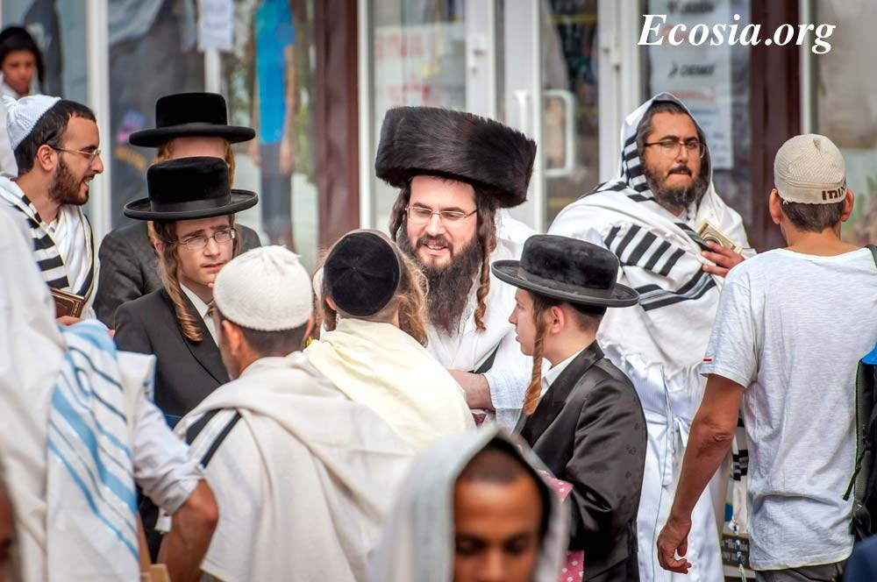
In 1862 a Jewish baby was born in the small town of Berezna, Hungary. There is some confusion concerning his birth name because at a young age he was adopted into another Jewish family. According to his 1908 autobiography, his birth name was Itzak Lieb Kahan (in English “Isaac Leopold Cohn”). He was raised in the Hasidic tradition. These are the Jews you see from Eastern Europe with the large fur hats and strange outfits. They are an ultra-orthodox sect of Judaism. Imagine it sort of like the Amish would be to evangelical Christians.
Leopold was an intently religious child. He studied in a Yeshiva (Jewish Hebrew school) and received instruction in the Torah under several different rabbis. According to his autobiography, he received his ordination under a rabbi named Zalman Lieb Teitelbaum in Hungary. As is the practice of many Hasidic Jews, Leopold searched the scriptures for clues of the Messiah and His coming. His studies brought him to the book of Daniel. As he did, he came across a verse that he just couldn’t get out of his mind.
²⁵ “Know therefore and understand, That from the going forth of the command
To restore and build Jerusalem Until Messiah the Prince, There shall be seven weeks and sixty-two weeks; The street shall be built again, and the wall, Even in troublesome times. (Daniel 9:25, NKJV).
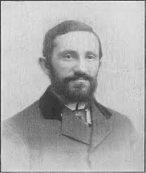
Leopold began to do calculations based on this prophecy, and according to his calculations at the time, the Messiah should have come about 2,000 years ago (right around the time of Jesus of Nazareth). He went to local Hungarian rabbis looking for help to understand this prophecy, but he couldn’t get answers that satisfied. One rabbi told him that he would need to go to New York to further investigate as some of the rabbis there were more familiar with the Messianic prophecies. Leopold Cohn packed his bags, and he and his young wife arrived in New York in 1892. Soon after he arrived, he was walking down the street and he passed by DeWitt Memorial Presbyterian Church in lower Manhattan. He saw a sign in Hebrew saying: “Meetings for Jews.” He went in and found an evangelistic service in Yiddish led by a Jewish missionary named Hermann Warszawiak. He was given a New Testament and shortly thereafter Cohn accepted Jesus as THE Messiah, as his Messiah.
Some sympathetic Christians gave him lodging and sent him to Scotland to receive theological training and to be tutored in English. He was baptized in Edinburgh in June of 1892. He studied for a year and then returned to New York where he worked for a while with the missionary who had led him to Christ. He then decided to go his own way in 1894 and started a mission called Brownsville Mission to the Jews. This eventually morphed into Chosen People Ministries which exists until today.
I have told this story to emphasize the importance of the events leading up to and involved in the day that we call “Palm Sunday.” God has incoded his plan of the incredible day in the Bible. The exact day of Palm Sunday was foretold in prophecy, and many of the events that occurred on Palm Sunday are laid out in God’s timetable. Palm Sunday presents a panoramic centerpiece of fulfilled prophecy. Let’s take a look at what Rabbi Cohn saw that sent him on the greatest hunt of his life.
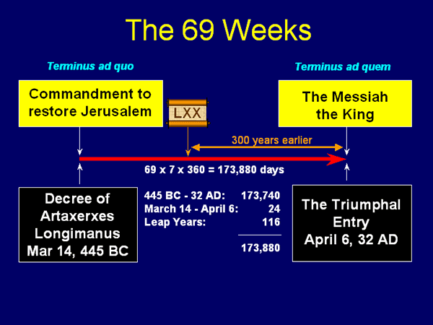
Nine years ago, when I was called to pastor the Grove, we began together with a study of the book of Daniel. At the Daniel chapter 9 mark, we learned of "69 weeks." We discovered that there would be exactly 483 years (counting Jewish years of 360 days) from a “command to rebuild Jerusalem” until the coming of the Messiah. King Artaxerxes gave Nehemiah permission to rebuild Jerusalem in Nehemiah chapter 2. From Babylonian records many scholars believe the command was given on March 14, 445 BC. Hence, in fulfillment of Daniel's "69 weeks," the Messiah revealed Himself exactly 173,880 days later when Jesus rode triumphantly into Jerusalem. It seems unbelievable that God would have really embedded the exact day of Palm Sunday into Daniel's prophetic scripture, but He did.
On that day, Jesus presented Himself to the world. The story of Passion Week actually begins in Bethany with the raising of Lazarus. Most are familiar with the story. Lazarus, whose real Hebrew name was Eliezer, was sick, and his sisters, Mary and Martha (whose names mean “bitter”), sent word to Jesus to come heal their brother. Most of us know the story line. Jesus purposely waited two days to leave from over the Jordan to come perform this incredible miracle.
Last week we uncovered the mystery of names that God used in the story. Lazarus means “God is my Help” and Bethany (the town where they all lived means) “House of Affliction.” We found ourselves in the story as each of us finds ourselves in periodic affliction, and, in faith, we learn that God is our only help. Both Mary and Martha basically scolded Jesus for not coming sooner. They figured that if He had come, Lazarus would have lived. Their attitude was one of bitterness - just as their names describe. We too can become bitter when we try to figure out the best way for God to solve our problems and our afflictions. So there, just two miles from Jerusalem, Jesus performed the most spectacular of miracles. Lazarus had been dead for four days, and Jesus raised him from the dead with a great host of witnesses. This story is personal to each of us, because if Jesus could raise Lazarus, He will be able to raise each of us!
The response of those who witnessed the miracle that day was huge. EVERYONE was talking about this rabbi Jesus who had literally called Lazarus forth from the grave. Verses 9-11 describe this response.

The Plot to Kill Lazarus
⁹ Now a great many of the Jews knew that He was there; and they came, not for Jesus’ sake only, but that they might also see Lazarus, whom He had raised from the dead. ¹⁰ But the chief priests plotted to put Lazarus to death also, ¹¹ because on account of him many of the Jews went away and believed in Jesus. (John 12:9-11, NKJV).
The religious leaders saw this miracle as a line in the sand. It was the last straw. In Spanish we say, it was “el colmo.” JESUS HAD TO BE STOPPED AND LAZARUS HAD TO BE KILLED. The text tells us that the very next day after Jesus’ “thank you” dinner in Bethany, the crowd went wild. They were so miserable under Roman rule that they felt Messianic fervor at what they had seen in Bethany. So they chose wholesale to believe that Jesus was the One. He was the Messiah, and He would finally lead them out from under the oppresive hand of Rome. The very next day after that Sabbath meal in Bethany, Jesus would ride in triumphantly on a donkey, and the crowds would go wild screaming: “Save us Son of David!” John records the account.

The Triumphal Entry
¹² The next day a great multitude that had come to the feast, when they heard that Jesus was coming to Jerusalem, ¹³ took branches of palm trees and went out to meet Him, and cried out:
“Hosanna!
‘Blessed is He who comes in the name of the Lord!’
The King of Israel!” (John 12:12-13, NKJV).

So, what does this mean? It doesn’t mean “praise Him” or “glory to God” or anything else like that. This is Hebrew for “SAVE US.” He Who comes in the name of the Lord is none other than THE MESSIAH. They were saying, “SAVE US OUR MESSIAH. YOU ARE THE SON OF DAVID, THE PROMISED KING OF ISRAEL.” What could possibly go wrong with this?

Brothers and sisters, we get into so much trouble when we try to turn God into what we want Him to be instead of receiving Him for Who He is. God is God and we are not. The crowd’s impression intensified as they saw Jesus come into Jerusalem riding on a donkey. They had all heard the prophesies read from Zechariah during their weekly Synagogue and Temple readings.

⁹ “Rejoice greatly, O daughter of Zion! Shout, O daughter of Jerusalem!
Behold, your King is coming to you; He is just and having salvation,
Lowly and riding on a donkey, A colt, the foal of a donkey. (Zecheriah 9:9, NKJV).
John repeats this in the text.
¹⁴ Then Jesus, when He had found a young donkey, sat on it; as it is written:
¹⁵ “Fear not, daughter of Zion;
Behold, your King is coming,
Sitting on a donkey’s colt.”
¹⁶ His disciples did not understand these things at first; but when Jesus was glorified, then they remembered that these things were written about Him and that they had done these things to Him.
¹⁷ Therefore the people, who were with Him when He called Lazarus out of his tomb and raised him from the dead, bore witness. ¹⁸ For this reason the people also met Him, because they heard that He had done this sign. ¹⁹ The Pharisees therefore said among themselves, “You see that you are accomplishing nothing. Look, the world has gone after Him!” (John 12:14-17, NKJV).
So, what are some lessons that we can learn from these events and the people in these events?
1. We all live in our own “Bethany.” By that I mean that we all experience afflictions, trials, and trouble. James, the brother of Jesus, was very explicit in explaining that we as believers experience suffering. He said, “² My brethren, count it all joy when you fall into various trials, ³ knowing that the testing of your faith produces patience. ⁴ But let patience have its perfect work, that you may be perfect and complete, lacking nothing. (James 1:2-4, NKJV).
2. We are all “Eliezer” (Lazarus). That means that to get out of affliction, we have only one path out of our misery. “God is my help.” Scripture tells us that “All things work together for good for those who love God for those who are called according to His purposes.” (Romans 8:28, author’s paraphrase).
3. We are all capable of becoming “bitter” when we don’t see God making a way in such a manner as we imagine that He should make it. That’s a mouthful, but what I’m saying is that we should beware of our propensity to play God and force our own expectations into the mix. We will end up being a Mary and a Martha that had great qualities, but they had not bridged the gap between their intellectual understanding of what Jesus could do with their emotions. We need to trust him with all of our hearts. That is where our minds and emotions meet. These last few weeks I’ve been thinking about the fact that faith isn’t just something we think. It must be something we live.
4. We must be careful to not be fickle followers of Jesus. When believing that Jesus was their earthly deliverer they screamed: “SAVE US OUR MESSIAH. YOU ARE THE SON OF DAVID.” Within six short days, when He didn’t meet their expectations, these same people would be screaming “CRUCIFY HIM.” We should be so careful lest we become bitter, blame God, and turn on Him when He doesn’t do things the way that we think they should be done.
5. Let’s now look at some positive things in the events of that day.
a. God’s Word is absolutely accurate, and biblical prophecy can be relied upon. We are so blessed that God reveals Himself to us in fulfilled prophecy. If past prophecies have been fulfilled, future prophecies will be fulfilled as well.
b. The events of Palm Sunday were accurately predicted in Daniel chapter 9. If we can depend on this, we can depend on every other prophecy that the Bible proclaims. God is faithful and He will perform what He has said He will do.
6. Lastly, I want us each to take a moment and contemplate with gratitude what our Creator and Lord did for each of us. He chose to come in the form of a human. He is ALL GOD and He is ALL MAN. He came and experienced what we experience. In John 11, the text tells us that Jesus wept. This was the God of the Universe, even while knowing that He would raise Lazarus, experiencing the desperation we humans feel when we experience either our own deaths, or the death of a loved one. This was never meant to be. This was not God’s plan. It was the rebellion and sin of man that brought this misery upon us. We were meant to live forever, but not in a broken world.
The writer of Hebrews tells us that we have a High Priest Who can sympathize with us in every way. That is because the Word was made flesh and dwelt among us, and we beheld His glory. The message of Lazarus was that there will come a day when He will call you forth from the grave. He said “Lazarus come forth.” And in like manner He will call you to eternal life with an incorruptible body. James, the earthly brother of Jesus tells us: ² My brethren, count it all joy when you fall into various trials, ³ knowing that the testing of your faith produces ^{[a]}patience. ⁴ But let patience have its perfect work, that you may be perfect and complete, lacking nothing. (James 1:2-4, NKJV). Palm Sunday tells us that it’s not all over. There will come a day when He WILL rule as Prophet, Priest, and King. I’m looking forward to that day. So, what should we do while we’re waiting? Naturally, if you don’t know this Jesus, today can be the day of your salvation. If you do know Him, then perhaps it is time to recommit yourself to follow Him with all of your heart, soul, and might. We must no longer be silent about Who Jesus is and what He offers to all of mankind.
Only the good doctor Luke records what Jesus said when the leaders told Him to hush up His followers. Let me read it to you.
³⁷ Then, as He was now drawing near the descent of the Mount of Olives, the whole multitude of the disciples began to rejoice and praise God with a loud voice for all the mighty works they had seen, ³⁸ saying: “ ‘Blessed is the King who comes in the name of the Lord!’ Peace in heaven and glory in the highest!” ³⁹ And some of the Pharisees called to Him from the crowd, “Teacher, rebuke Your disciples.”
⁴⁰ But He answered and said to them, “I tell you that if these should keep silent, the stones would immediately cry out.” (Luke 19:37-40, NKJV).
THE KING CAME – AND THE KING IS COMING AGAIN – GIVE HIM PRAISE, HONOR, AND GLORY!
BECAUSE IF WE DON’T, ALL OF CREATION WILL CRY OUT IN PRAISE.
Let us pray.

Union Grove is one of the oldest Baptist communities of faith in the State of Texas dating back to 1844. Pastor Faber McMullen may be reached by email at uniongrove362@gmail.com or by snail mail at: 15301 FM 362, Navasota, Texas 77868. Tel: 936-825-1227 (Edited and proofed by Amanda Neese- Webster, Texas.) All financial gifts to this ministry are tax-deductible as a 501 (c) (3) Corporation.

https://chosenpeople.com/about/our-history/
https://www.khouse.org/articles/2008/769/

