20241020 Hebrews 5:1-14 – Time To Grow Up

Last week we were introduced to the idea of Jesus as our High Priest. We learned that He is a Priest who can sympathize and empathize with our every need. The Jewish people had had very definitive ideas of the priesthood, High Priests, etc. It was very integral to their Jewish faith with regard to their relationship with God. The whole idea of “priesthood” is a bit complicated to our Greek-thinking Gentile minds. The writer is writing to clarify that Jesus is our new HIGH PRIEST and what exactly that role means to each of us.

We don’t think much about priests because we know as Gentile Christians that we’re all priests in a theological way. The concept of the “Priesthood of the Believer” is central to Baptistic systematic theology. We need no mediator to have a relationship with God. We approach the throne of grace through the provision that Jesus made for you and me. This concept was unknown to the Jewish mind. The priest was the intermediary between man and God. You couldn’t get to God without going through the middleman.

The Priest was the one who handled your sacrifices for you. He was the one who presented all the gifts that you might desire to give to God. He represented you to God and he represented God to you. The writer has said that it is Jesus that is now our High Priest. He begins by reviewing the requirements for a person to be a high priest under Levitical Law.

5 For every high priest chosen [special agents with certain specific qualifications] from among men is appointed [called by God] to act on behalf of men in relation to God, to offer gifts and sacrifices for sins. ² He can deal gently with the ignorant and wayward, since he himself is beset with weakness. ³ Because of this [priest being a sinner] he is obligated to offer sacrifice for his own sins just as he does for those of the people. ⁴ And no one takes this honor for himself, but only when called by God, just as Aaron was. [This sacred duty was only by those who were called by God and had gone through the ritual of offering sacrifice for their own sin. A priest could only come from the Tribe of Aaron (Levi).] (Hebrews 5:1-4, ESV with author’s notes in brackets).

We see within these first verses that there are four qualifications to be a priest:

- A priest must be human. He must be from “among men.” He cannot be an angel. He cannot be God. He must be a human to “act in behalf of men.”

- He must function both relating to “gifts” (meal offerings) and “sacrifices” (blood offerings).

- He must be compassionate and sympathetic. That is the advantage of being human. An angel can’t feel what we feel. A God can’t experience what we experience. A priest must experience what humans experience to know how to represent them to God. He must be able to “deal gently” (to treat others with kindness and moderation). He must be able to avoid extremes of apathy and excessive feeling.

- He must be appointed by God. That means a “divine appointment” is necessary. Aaron was singled out by God in Exodus 16:33, and he was specifically called to the priesthood in Exodus 28:1. He was reconfirmed as God’s called vessel in Numbers 17:8. In scripture, anyone who tried to act as a priest without the calling of God was rejected by God. Korah led a rebellion against Aaron and Moses and God killed him and had the earth swallow him up. In impatience, King Saul sought to perform his own sacrifice and God rejected him as priest and then as king (1 Samuel 13:5-14). When King Uzziah attempted to burn sacrificial incense, God struck him with leprosy (2 Chronicles 26:16-23). God took the calling of priesthood very seriously.

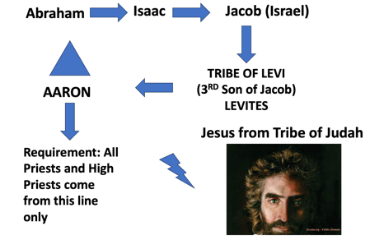
God is serious about whom He calls to ministry and where He calls them to minister. Under the old convenant, only descendants of Aaron were qualified. I would add that some of these qualifications can be applied to a pastor in a local church. I am in no way implying that a pastor has the role of a priest in a church, but without a calling, his ministry will be unfulfilling and unproductive. The Bible is clear that it is a “calling” (Ephesians 4:11). This doesn’t mean a pastor who pastors a church that doesn’t grow in numbers is unqualified. A pastor’s job is to grow those who are there and to pour his life into them. I am thinking right now of a pastor named Floyd Tuckett, who ministers outside of Texarkana. Sandy and I have visited him and his family a few times. He started seminary in 1973 and finished in 1976. A year or so after seminary he was preaching full time and then he bacame bi-vocational like Paul. He has been at the same little church since 1980. For thirty-four years he has faithfully pastored a modest congregation that now numbers maybe 12 people. His congregation has steadily drifted down in numbers as people have died and or moved on. He is faithful in teaching the Word and in loving his people. That is a faithful, called pastor. That is the kind of call that God puts on certain men’s lives.

Years ago, when the Grove was struggling, a member came to me and asked whether there was a time when a pastor should be removed. I asked whether the pastor had been involved in some moral scandal, or whether he was teaching heresy. The answer to both questions was “no.” I cautioned him not to bring harm or try to remove a person who had been called to a ministry by God. I told him that nothing good would come of that. In time, God moves things around as He desires and brings others to serve for another season in His church. In the pastorate, there are very specific requirements laid out in 1 Timothy chapter 3, and there are specific circumstances for removing someone (but that’s another sermon for another day).
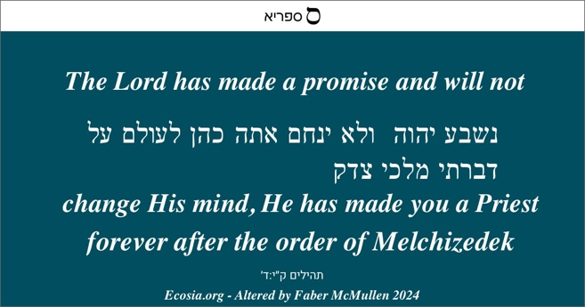
⁵ So also Christ did not exalt himself to be made a high priest, but was appointed by him who said to him, “You are my Son, [Psalm 2:7 quotation] today I have begotten you”;
⁶ as he says also in another place,
“You are a priest forever,
after the order of Melchizedek.” Messianic Psalm 110:4 quotation] (Hebrews 5:5-6, ESV with author’s notes in brackets).

These verses offer an explanation of how Jesus qualifies as a High Priest under the New Covenant. It’s the same four qualifications, but they are presented in a different order. The writer explains that an order of priests existed (even before Abraham) that was superior to the Levitical priesthood that was to come later with Aaron. Approximately one thousand years before Jesus came, there was a man who was a “priest of the Most High God,” and not only was he NOT of the Tribe of Levi, he wasn’t even a Jew. He wasn’t from the Tribe of Levi. He wasn’t a descendant of Aaron. He preceded all of that.

God spoke prophetically through David concerning the Messiah who was to come, and he said that the Messiah himself would be a priest in the order of Melchizedek. He was a man that was both a priest and a king. Melchizedek was a priest before there was a priesthood. I used to think that perhaps Melchizedek was a Christophony, but I’ve come to think otherwise. The text says that Jesus came κατὰ τὴν τάξιν Μελχισέδεκ (kata tén taxin Melchizedek)“after/according to the order/position/rank of Melchizedek.” Jesus came, and He was the kind of priest just like Melchizedek. Let’s save further discussion of Melchizedek for Chapter 7.

Remember our last verses of last week’s study. The High Priest was “one of them” and Jesus is “one of us” as well, but Jesus was perfect and without sin. It makes Him able to relate to and identify with us, and we to him.
¹⁵ For we do not have a high priest who is unable to sympathize with our weaknesses, but one who in every respect has been tempted as we are, yet without sin. ¹⁶ Let us then with confidence draw near to the throne of grace, that we may receive mercy and find grace to help in time of need. (Hebrews 4:15-16, ESV).

Last week, we spoke about how when we’re overcome with guilt because of our faults and failures, our response should be to lay it all out before this Priest Jesus Who understands it all!

⁷ In the days of his flesh, Jesus offered up prayers and supplications, with loud cries and tears, to him who was able to save him from death, and he was heard because of his reverence. ⁸ Although he was a son, he learned obedience through what he suffered. ⁹ And being made perfect, he became the source of eternal salvation to all who obey him, ¹⁰ being designated by God a high priest after the order of Melchizedek. (Hebrews 5:7-10, ESV).

This can be a difficult passage for us to comprehend because, knowing that He is God, we wonder how we can explain his “loud cries and tears.” We must remember that Jesus was 100% man and He was 100% God. It is strange to even read here that Jesus Christ “learned obedience through what He suffered.” How does God learn obedience? He was never disobedient, but He acquired “Yadah” (experiential knowledge) as to what it takes to be obedient. We must remember that He experienced things that He never would have experienced had He not been born as a human. It would have been impossible. So, we literally see God in the flesh exposed to our own kinds of suffering, and in it, He completed the mission that He had been sent to complete.

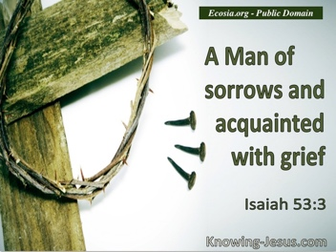
We now transition from His suffering into our own suffering. We too learn from our suffering. I so much wish that we (you and I) didn’t have to suffer. When we offer our suffering up to God, it can somehow be used for His glory. God turns that suffering into tools to transform us into the image of His Son. I have often taught that when we see things we just can’t understand, and when the suffering seems to great to bear, we must start with the premise that God is good. Start with that. Hold fast to that! Jesus learned obedience by what He suffered, and so can we. Let’s comfort ourselves for a moment reading the words of Paul concerning suffering.

¹⁸ For I consider that the sufferings of this present time are not worth comparing with the glory that is to be revealed to us. (Romans 8:18, ESV).

²⁸ And we know that for those who love God all things work together for good, for those who are called according to his purpose. ²⁹ For those whom he foreknew he also predestined to be conformed to the image of his Son, in order that he might be the firstborn among many brothers. (Romans 8:28-29, ESV).

Now, the writer discusses the need for spiritual growth and maturity. He is having a hard time explaining all of these concepts to these readers because of their lack of spiritual maturity.

Thus far in the study of Hebrews, we’ve seen two main warnings:

THE FIRST WARNING – THE DANGER OF DRIFTING – Hebrews 2:1-4
THE SECOND WARNING – DANGER OF DISOBEDIENCE – Hebrews 3:7-4:13

The writer now presents a third warning. It is the warning of failing to mature, to progress spiritually in our lives.

THE THIRD WARNING – FAILING TO PROGRESS SPIRITUALLY

¹¹ About this we have much to say, and it is hard to explain, since you have become dull of hearing. ¹² For though by this time you ought to be teachers, you need someone to teach you again the basic principles of the oracles of God. You need milk, not solid food, ¹³ for everyone who lives on milk is unskilled in the word of righteousness, since he is a child. ¹⁴ But solid food is for the mature, for those who have their powers of discernment trained by constant practice to distinguish good from evil. (Hebrews 5:11-14, ESV).

The writer goes on to say that these things are hard to explain. It is especially hard when our hearts are hardened. Our hearts become hard when we are unable to perceive what is going on in our lives from a spiritual perspective. We can’t have the right perspective without being grounded in sound Bible doctrine and in the deeper things of the faith. The author chastens the readers, telling them that it is WAY PAST the time when they themselves ought to even be teachers, but they’ve never gotten the basics down. He says that they’ve never gotten down to the “basic principles of the oracles of God.” What could this possibly be talking about?

There are several different places in scripture that mention the “oracles of God.” The Greek phrase used is often logion Theou. This is the plural form of the word logos followed merely by “of God.” You might remember during last week, that I mentioned that on one level, in classical Greek, logos meant “the fact” and ”the fact explained.” In Acts 7:38, Stephen spoke of how Moses brought the “living oracles to us.” That speaks to the life-giving nature of God’s Word. In our recent study of Romans, we saw that the “oracles of God” were entrusted to the Jews (Romans 3:2). And we, the Gentiles, have benefitted from those oracles. Paul follows that dialogue explaining through the entire plan, both Jews and Gentiles now have full access to righteousness and hence to salvation from sin and self.

So in this particular case, I think the “oracles of God” are the basics including such spiritual things as:

- What is the Gospel?
- How are we saved?
- What is repentance unto salvation?
- What is the purpose of baptism?
- What is positional sanctification (righteousness)?
- What is progressive sanctification (godliness)?
- How does a believer grow in faith?
- How is the mind transformed?

- What is the evidence of God working in our hearts and lives?
- What does it look like when we revert to flesh-patterns of behavior?
- How do we handle temptation?
- What is repentance unto godliness?
- How do we get back on track when we’ve strayed?
- What does true discipleship look like?

When we don’t move on from the fundamental “oracles of God” we are like old people who are still in the nursery ward at the hospital. Wouldn’t that be a horrible site to see? Don’t be that! Move on! Become skilled! Otherwise, you’ll sit on the spiritual sidelines, never understanding and without any powers of discernment. That’s not where God wants us to be. Let’s get these things down, otherwise we’ll never be able to distinguish good from evil.

Let us pray.

Union Grove is one of the oldest Baptist communities of faith in the State of Texas dating back to 1844. Pastor Faber McMullen may be reached by email at uniongrove362@gmail.com or by snail mail at: 15301 FM 362, Navasota, Texas 77868. Tel: 936-825-1227 (Edited and proofed by Amanda Neese- Webster, Texas.) All financial gifts to this ministry are tax-deductible as a 501 (c) (3) Corporation.

