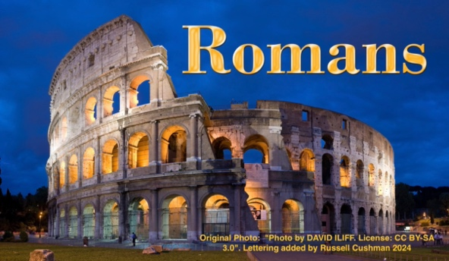
20240428 Romans 1:1-7 – Bondservant of Jesus

This letter was written to believers who had started a church or various churches in Rome, the great capital city of the Roman Empire. We’re really not sure how this group first came into being, but Paul is writing this epistle (letter) to those believers before he ever had a chance to visit them. As mentioned last week, we know that Jews had come from Rome and were visiting Jerusalem on the day of Pentecost (Acts 2:10) More than likely, many of those became believers and took the gospel back to Rome.

Many scholars think that perhaps Priscilla and Aquila were part of those who had been in Jerusalem at Pentecost, and that they had come back home to Rome after and had been at the center of this early Roman church. Then Emperor Claudius expelled the Jews from Rome some time thereafter during his reign (41-54 AD). Roman historian Suetonius mentions “disturbances” by Jews surrounding someone called the “Christus.” In Acts we read “because Claudius ordered all Jews to leave Rome” (Acts 18:2). Historians Josephus and Orosius also mention the expulsion. So at this point the Jewish believers in Rome had to leave. This would have included Priscilla and Aquila. Claudius is one of four Roman emperors mentioned in the New Testament.

Having been expelled from Rome, they made their way to Corinth, where they met Paul. One and a half years later, Paul moved to Ephesus and took the couple with him. They remained there and were quite the dynamic duo in their ministry. Timothy was pastor in Ephesus, and Paul mentions them in his later letter to Timothy. ¹⁹ Greet Priscilla and Aquila, and the household of Onesiphorus. ²⁰ Erastus stayed in Corinth, but Trophimus I have left in Miletus sick. (2 Timothy 4:19-20, NKJV).

During the time that the Jews were exiled from Rome, the church community continued to grow. When the Jews began moving back after the death of Claudius, they found themselves in the minority, and learned that they were now looked down upon by their fellow Gentile church members. Part of the discussion in Romans by Paul is his reminding the Gentiles about the unique calling of Israel and its special relationship with the Lord through God’s covenants with the Jewish people.

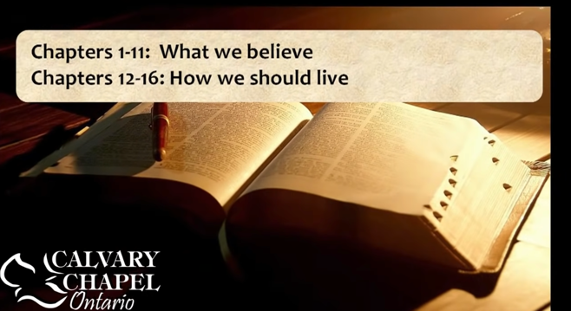
I have heard a great Bible teacher (my wife) explain that the Church is a like a table top resting on the legs of Judaism. Without an understanding of these legs, one has an incomplete understanding of the Church. Since Jesus came, the action takes place on the tabletop. Just imagine how difficult it was for the Jews and the Gentiles to envision what the Church was all about because the Church isn’t hinted of nor does it even appear in the Old Testament. Imagine being a young believer in Rome, having no Bible to study nor having a complete understanding of how and what Jesus’ death, burial, and resurrection meant. The Book of Romans is foundational. As a lawyer, I like to think of it as the framework or constitution of the Church. In the Book of Romans, Paul explains how the Church fits into the history of God reaching out to human beings.

The book is divided in two great parts. Chapters 1-11 deal with “what we believe as Christians,” and chapters 12-16 address the issue of “how we should live as Christians.” The categories can be further broken down per the chart below. You have this in your bulletin.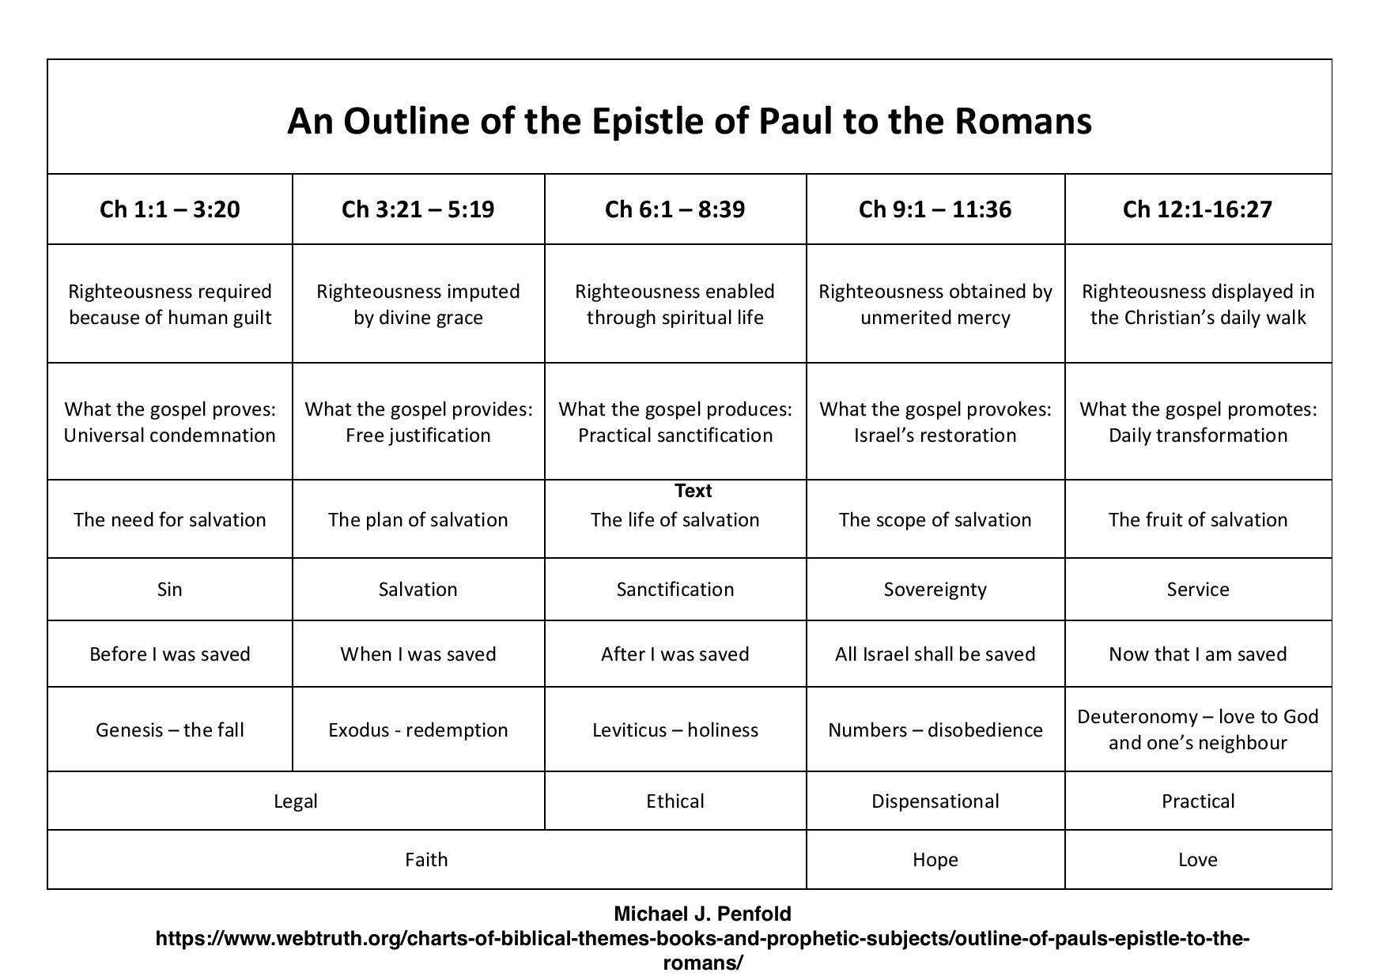
Remember that the cornerstone of this epistle is the word righteousness. In both Hebrew (zadek) and Greek (diakosyne) the word that is translated into English as “righteousness” has sort of a double definition. It is righteousness and justice. It’s origin means “faithfulness to your covenant”. Death of Christ is “diakosyne” means that the death of Christ shows God’s “faithfulness to His covenant.”
Righteousness has to do with the “standard” of something (God’s standard).
Justice is the “application of that “standard.” Let’s now work our way through the text itself.
¹Paul, a bondservant of Jesus Christ, called to be an apostle, separated to the gospel of God (Romans 1:1, NKJV).
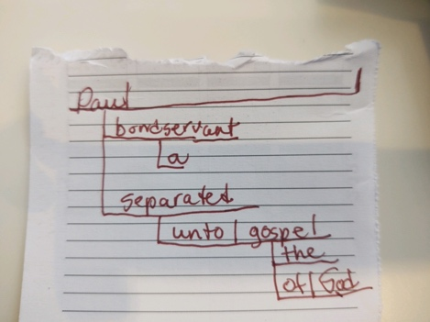
A Bondservant – As I started my study, I was captivated by Paul’s introduction of himself. After his name, he describes himself as a “bondservant” of Jesus. If you’re a bit of a grammar student like myself, you will understand this is structured perhaps as a predicate nominative or some sort of nominative modifier of the name Paul itself, tagged with two past participles; called and separated. These are used as a descriptive adjectives. So what am I saying with this bit of grammar? When a person introduces themselves, how they introduce themselves tells you a lot about what they believe about themself. Paul is being very direct about who he is and what he's all about. He is telling us in the first sentence, I AM A BONDSERVANT of Jesus CHRIST, SENT BY GOD AND SET APART FOR THE GOOD NEWS!
A bondservant was a person who willingly became a servant/slave to his master. This was laid out in the Torah, which had a section that protected Hebrew servants by restricting bondage to six years (Exodus 21:2, Deuteronomy 15:12). However, after such a time period, if a servant wanted to stay with his master, God put a contingency in the law for that. This reminds me of a ranch worker who worked for me years ago. When I was counseling him and asked him what he wanted to do with his life, he said, “I just want to work for you. That’s what I want more than anything else. I want you to take care of me and let me take care of your needs on this ranch. I want to learn all that you can teach me and I want to spend my days with you.” In biblical times, such a servant would be taken to the city gate (before the judges) to declare his desire to serve, and he would then have his ear pierced in the door of the home. Paul is saying I am such a servant to Jesus. My time, talents, and all else that I am and have are His completely for the rest of my life. A quick internet search gives the following beautiful explanation of the believer being a bondservant of Jesus.
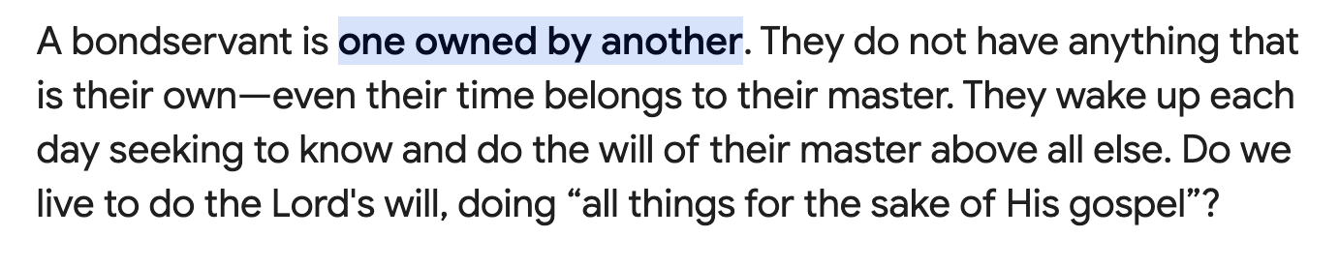
Additionally, Paul introduces himself as an “apostle.” “Apostle” comes from the Greek word meaning “to send.” Paul is saying that he was personally sent BY GOD to serve. There are some churches out there that call their pastors “apostles.” Well, there are no “apostles” anymore. We don’t need to disparage or denigrate those who use such a term, but it is important that we understand that the only true apostles were those “sent” directly and personally by God at the beginning of the church age.
Such a calling ended with those who were first called out to enact the “kerygma” (the apostolic calling to proclaim salvation through Jesus Christ). That is the term used in seminary studies for the great time of expansion of the gospel that occurred in the years after Jesus ascended into heaven. It began in Jerusalem, and during the lives of Paul and the other apostles, it ignited and spread like a fire into what are now the countries of Greece, Turkey, and other countries of the near Middle-East.
So, Paul, this bondservant slave of Jesus, was directly and personally SENT BY GOD. He was “set apart” to the “Gospel of Jesus Christ.” It’s good to remember that “holy” actually means “set apart.” Paul is saying, “I am a servant-slave of Jesus, and God sent me, and I am set apart to serve Him. That’s my purpose.”
Purpose is an essential element in each of our lives. People will die without a purpose (and I will add a meaningful purpose). You and I need a purpose. I remember a Star Trek episode where the wise theologian Captain Kirk explained to an alien that human beings need to overcome hardships in order for them to feel purpose. Without that, they will perish. That is because overcoming hardship is one of the things that gives us purpose. So, it does each of us good to ask ourselves from time to time, “What is my purpose?” You’ve heard me say that God gives us each a: (1) purpose, (2) a plan, and (3) a place. So that’s something you can lay before the Lord. It’s okay to ask God to continue to reveal what He wants to be the focus of your life, how He wants you to accomplish that, and where He wants you to accomplish that.
I think those three things can change over time in our lives as well. At this point in my life, my overriding purpose is to pastor this congregation both by sharing the gospel and by encouraging each of you in your growth in Christ. At present, it seems that His plan is for me to do that as long as I am physically and mentally able to do so. And not only that, He has called me to do this in this holiest of places. You might ask, “Pastor, why do you call Union Grove Baptist Church of Whitehall “The holiest of places?” I think this is in part because this community of faith was “set apart” by relatives of mine on my mother’s side. Eliza Collins Camp, and her husband, Ira Camp came to Whitehall in 1848 and they formed the “Muldrew Meeting House,” which was either in this place or near this place. I believe it evolved into the congregation here at Union Grove in which we all serve and attend today. Another distant relative of mine on my father’s side, Dougal McAlpine, gave three acres here to be devoted to a school and this church. I came here not knowing any of this, but it helps me to understand that this place is “set apart” not only for me, but for all who have been led here and all who feel led to join in what God is doing here. We are in a good place. This is a holy place, and we have a holy purpose. We have work to do.
Maybe at this point, you are not sure of your purpose. You’ll have to pray about it and listen closely to that still, small voice within you. Don’t let the world define this one for you. You need to live your life “God-ward” and “outward.” You don’t want to live your life “self-ward” and “inward.” That is following the world’s standards and is self-centered. I will add that this comes naturally to NO ONE. It does not come easily to any of us. Our natural tendency is to live for ourselves. We have to battle that tendency daily. Our purpose is to please Him and serve Him with all our hearts. The paradox is that when we are serving as bondservants to him (when we’re sold out to Him), peace, satisfaction, and true freedom come into our lives. Let us continue.
[This gospel] ² which He promised before through His prophets in the Holy Scriptures, ³ concerning [περὶ - peri] His Son Jesus Christ our Lord, who was born of the seed of David according to the flesh, (Romans 1:2-3, NKJV with author’s notes in brackets).
Paul firmly grounds his argument in the Old Testament. This Book of Romans cannot be viewed correctly without looking back into the Old Testament. Paul quotes the Old Testament often in his letters, and half of all the quotations that Paul gives out of the Old Testament are found in the Book of Romans. Here, he is saying that the prophets of old (the Jewish prophets in the Tanakh) foretold of Jesus the Messiah throughout scripture. Paul uses two loaded Old Testament terms: (1) Jesus was born of the seed of David, and (2) he was declared to be the “Son of God.” Paul is prefacing all that he is going to say by declaring that the GOSPEL IS ALL ABOUT JESUS! Have you ever noticed that when you try to discuss the gospel with others, if the discussion revolves around Jesus, people will listen? But if you try to make the gospel about something else (church membership, baptism, a list of dos and don’ts), you won’t find a willing listener? Paul uses the Greek word “peri” to say it all concerns and is all about Jesus. Peri is the word from which we get perimeter, pericardium, and periscope.

The image to the left is the perimeter of McMullen Farm. If you want to know ALL ABOUT MCMULLEN FARM you look at everything within the perimeter of McMullen Farm.
Paul is saying that if you want to know all about this “gospel,” it’s really ALL ABOUT and SURROUNDS Jesus, the Messiah. He was born out of the seed of David according to His earthly genealogy. THE GOSPEL IS ALL ABOUT HIM. Be careful when you talk to others that the conversation doesn’t move from Jesus to religion. It is everything surrounding Him; including God’s plan, purpose, and place for coming in the flesh as Jesus Christ.
I would caution you not to argue with people about religion and Church history. Just stay focused on Jesus. Talk about what He did and what He taught. Talk about the resurrection and what it means to you. Talk about how Jesus has made a difference in your life. Our faith must always be “Christ-centered.” It all emanates from there. Whatever is outside of Jesus is superfluous.
Paul then calls Jesus our “Lord.” While we’re looking at words, you might be interested to know from whence we derive the word “Lord.” It is from two Saxon words, “loaf-ward.” That is the “bread keeper.” And isn’t that exactly what He is to each of us? He is the provider and sustainer of everything about us. Without Him there is no purpose. Listen to the words of the Lord Jesus. I realize that is not the meaning of the word in Greek, but it’s a beautiful word that developed in our own language to express this.
³³ For the bread of God is He who comes down from heaven and gives life to the world. ³⁴ Then they said to Him, “Lord, give us this bread always.”³⁵ And Jesus said to them, “I am the bread of life. He who comes to Me shall never hunger, and he who believes in Me shall never thirst.” (John 6:33-35, NKJV).
In the letter to the Romans Paul continues: ⁴ and declared to be the Son of God with power according to the Spirit of holiness, by the resurrection from the dead. ⁵ Through Him we have received grace and apostleship for obedience to the faith among all nations for His name, ⁶ among whom you also are the called of Jesus Christ; ⁷ To all who are in Rome, beloved of God, called to be saints: Grace to you and peace from God our Father and the Lord Jesus Christ. (Romans 1:4-7, NKJV).
We’ve been given grace and apostleship for “obedience to the faith.” What is grace? It is favor that we never deserved. Some obedience comes from following rules. For Jews, obedience involved following what Paul called “the law.” Paul isn’t talking about obedience through fear or intimidation. He is talking about an obedience that is accomplished through faith and faith alone. THIS IS AN OBEDIENCE THAT COMES THROUGH FAITH. It is an obedience that says, “JESUS I AM GOING TO TRUST YOU AND YOU ALONE.”
You’ll stay obedient by faith and faith alone. It is that day by day continuous abiding and trusting in Jesus and His promises. We talked about this Wednesday night as we studied John 8.
³¹ Then Jesus said to those Jews who believed Him, “If you abide in My word, you are My disciples indeed. ³² And you shall know the truth, and the truth shall make you free.” (John 8:31-32, NKJV).
Many fail here because they don’t realize that victory doesn’t come by rules and instruction and morés, but rather by faith. Yes, there is a condition there. It is IF WE ABIDE IN HIS WORD. There have come times when I’ve just had to say, “God, I want to walk in obedience to you, and I don’t want to do this one thing that I know is contrary to what you desire for me, but I’m doing this because I have faith in You and the power of your word and LORD MORE THAN ANYTHING I DESIRE WHAT YOU DESIRE FOR ME.” The key to victory over our flesh is faith. And how do we get more faith? So then faith comes by hearing, and hearing by the word of God. (Romans 10:17, NKJV).
So, as we wrap things up this week, let me ask you if you are a “saint.” Have you accepted Jesus Christ and His work on the cross for your salvation? If you have done so, you are a saint. Recommit yourself to be a “bondservant” of Jesus, realizing that you are called and understanding that you are separated for Him. Recommit to seeing your faith in Jesus as the central point of your journey as a Christian. Look to Him and Him alone to be your shield, your buckler, and your sustainer. Understand this morning that if you are Christ-centered and Jesus-focused in your life there is no greater purpose. Understand once more that you are “blessed and highly favored” (a recipient of grace). Your obedience is initiated and continued by faith. That faith is trusting that God is Who He says that He is and that He will do what He says He will do. When you have done that thing, you are one of His “called.” You are His “chosen.” What a privilege and a joy it is to serve as a “bondservant” of Jesus. It is the greatest freedom each of us can ever know!
Let us pray.
Union Grove is one of the oldest Baptist communities of faith in the State of Texas dating back to 1844. Pastor Faber McMullen may be reached by email at uniongrove362@gmail.com or by snail mail at: 15301 FM 362, Navasota, Texas 77868. Tel: 936-825-1227 (Edited and proofed by Amanda Neese- Webster, Texas.) All financial gifts to this ministry are tax-deductible as a 501 (c) (3) Corporation.

https://publications.morningstarministries.org/word-for-the-week/bondservants-christ-book-revelation#:~:text=A%20bondservant%20is%20one%20owned,the%20sake%20of%20His%20gospel%E2%80%9D%3F

